EKS Create in AWS

- Create a role in AWS
Go to IAM Roles
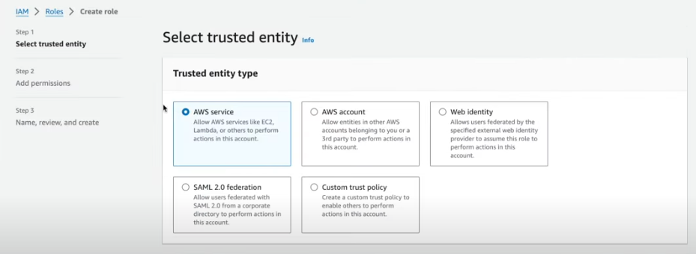

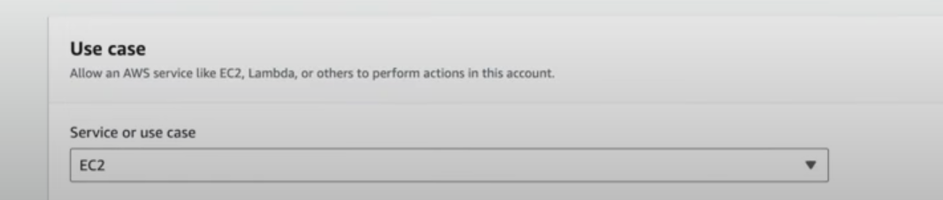

Choose Admin access

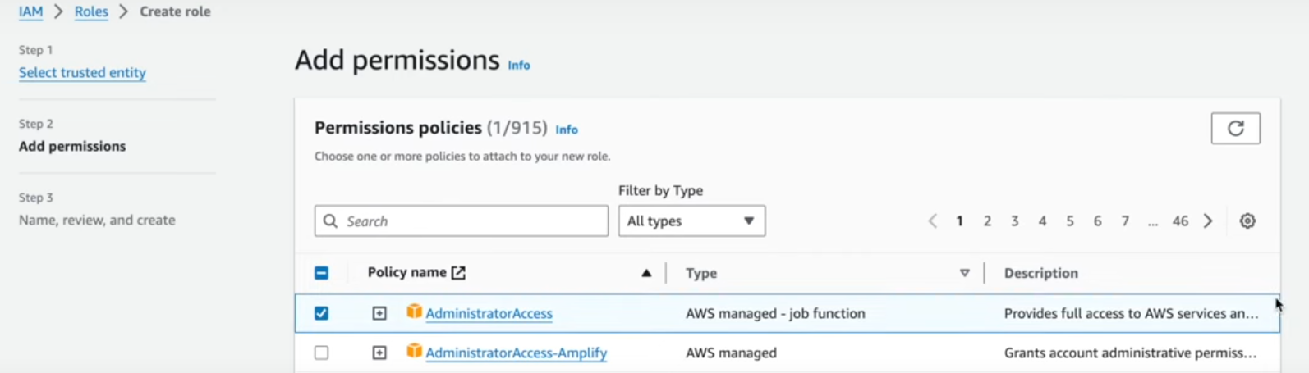

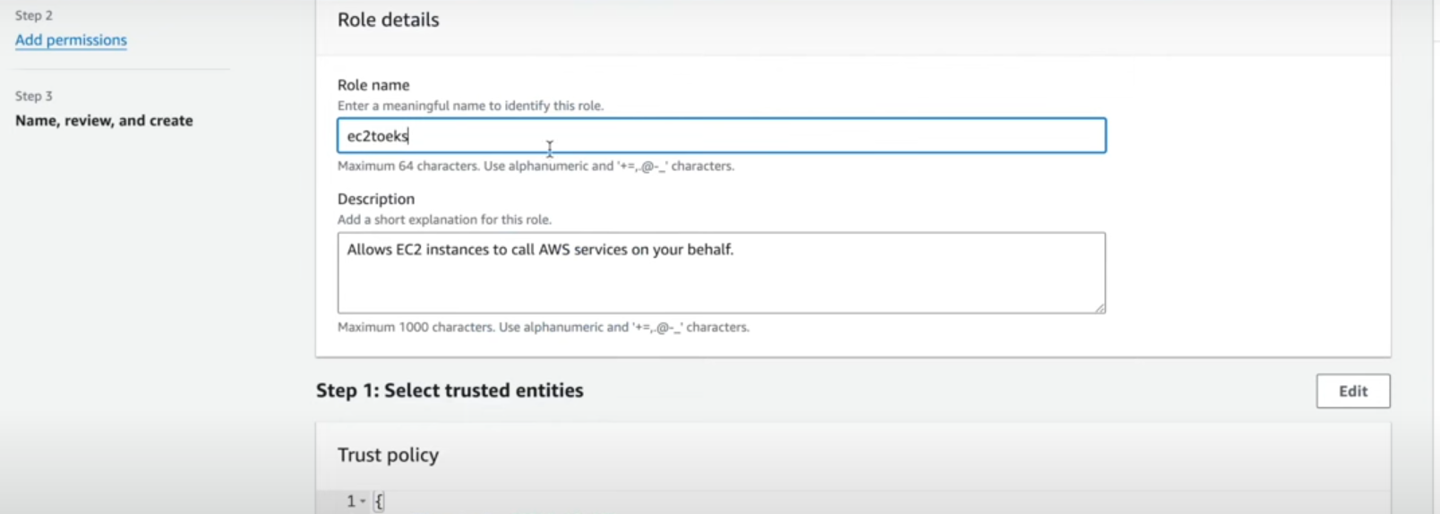

Select to Create a role

Now create a EC2 instance choose Ubuntu image only T2 medium or more than that

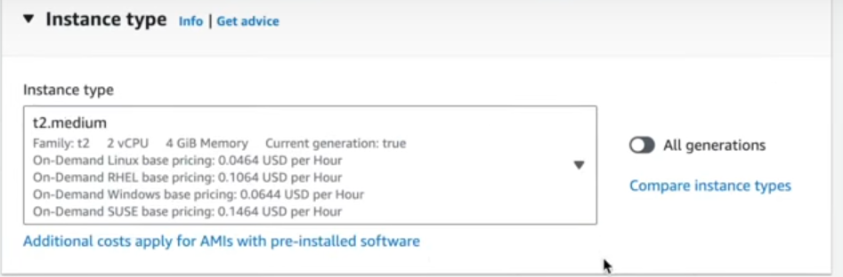

Choose VPN

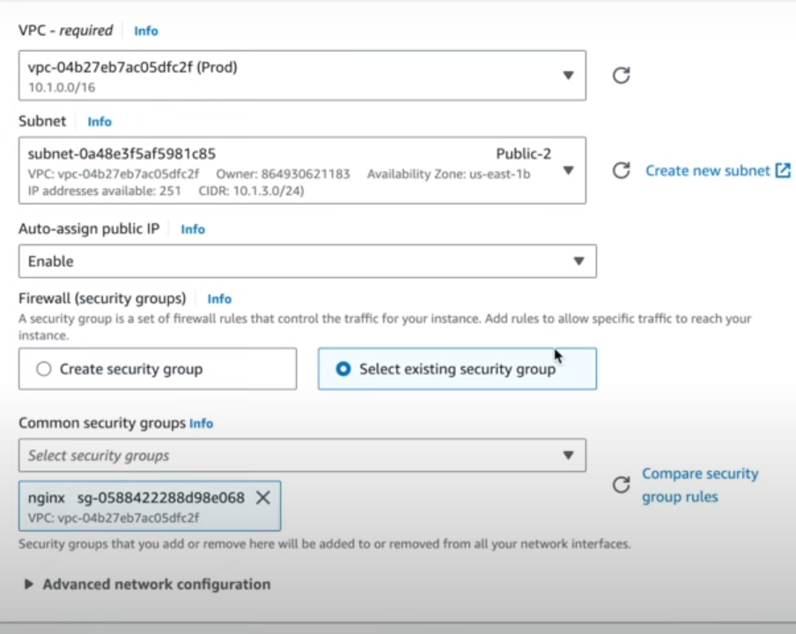

Once VM is Upon running then attach IAM role to that server

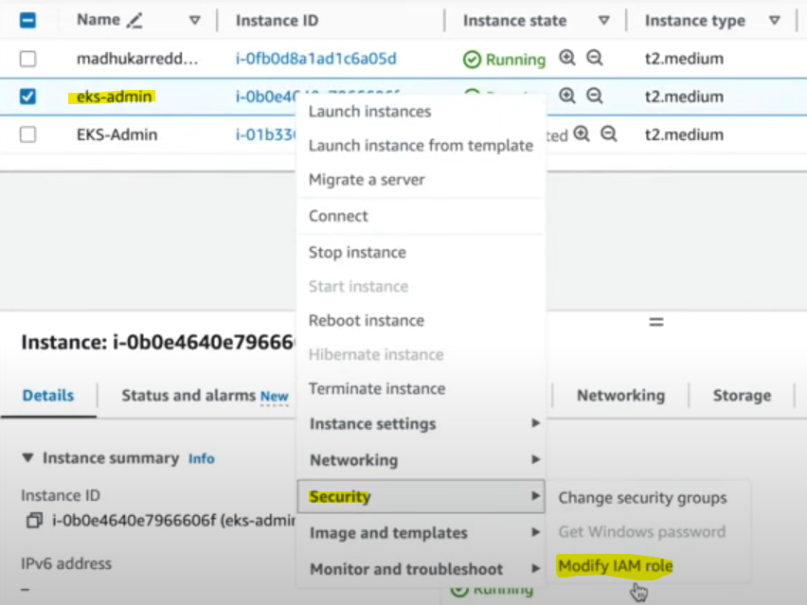
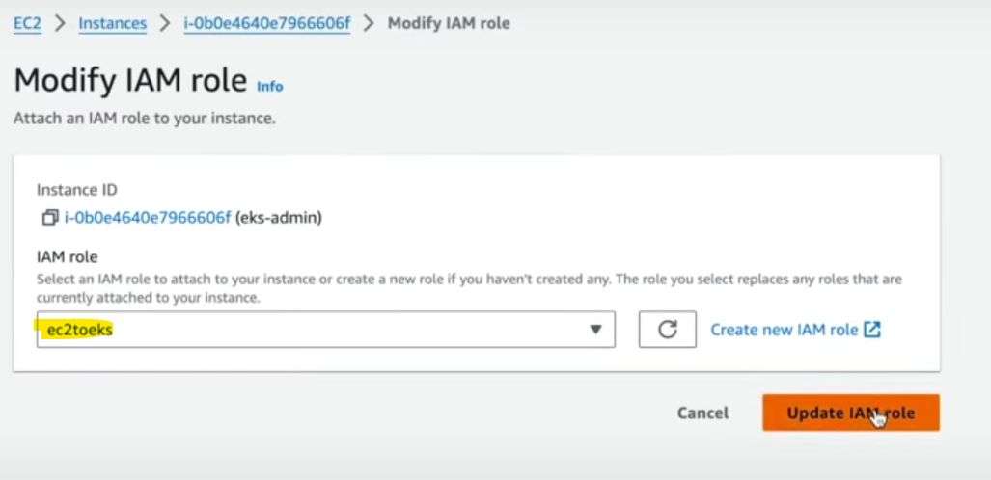

Login to server and switch to Root user and update sever and install unzip tool

Now install AWS Cli

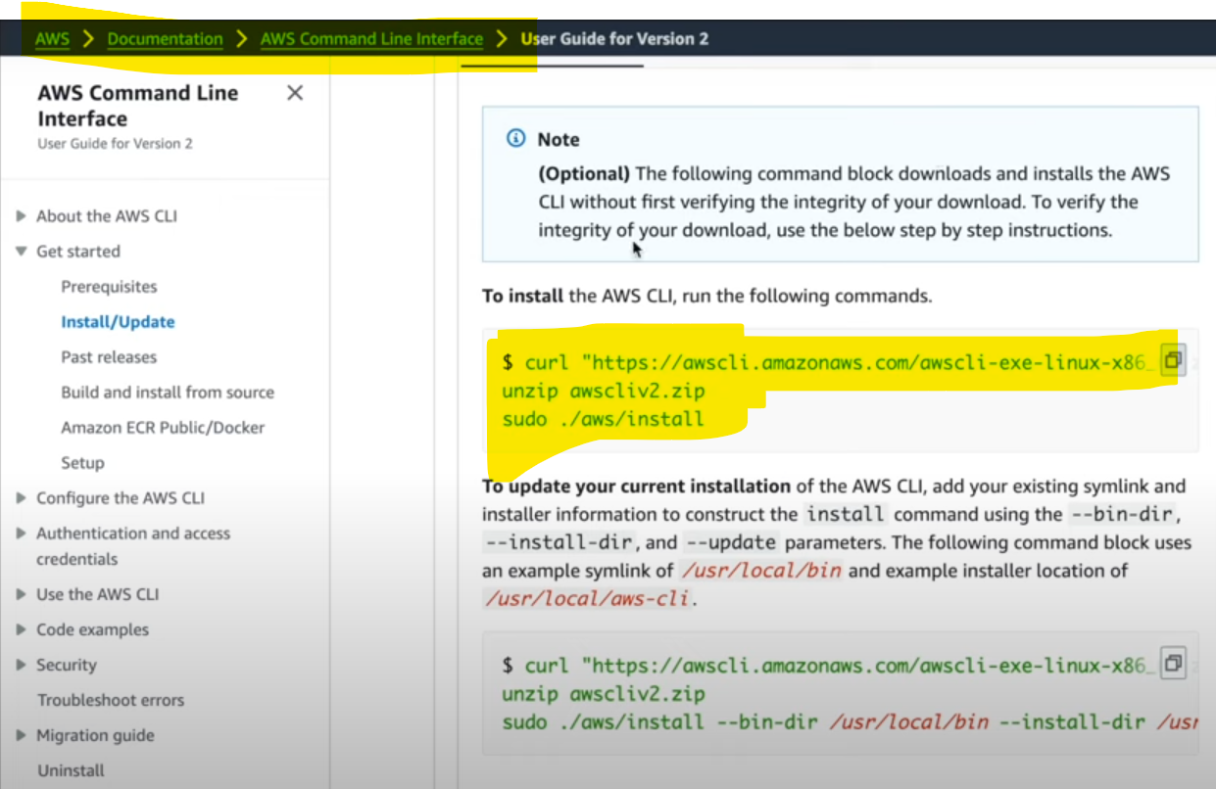
Curl https://awscli.amazonaws.com/awscli-exe-linux-x86_64.zip -o “awscliv2.zip”
Unzip awscliv2.zip
Sudo ./aws/install
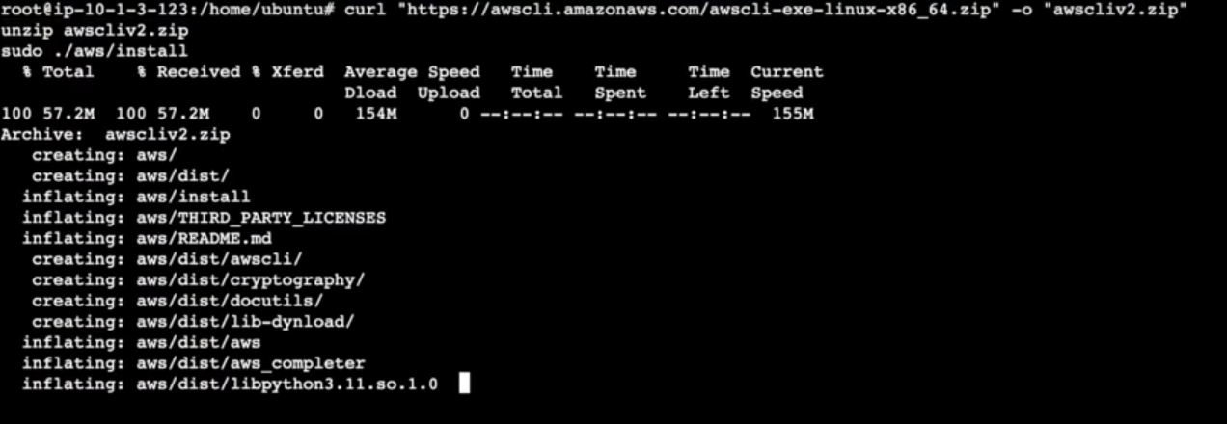

Once installed check the version
Aws --version
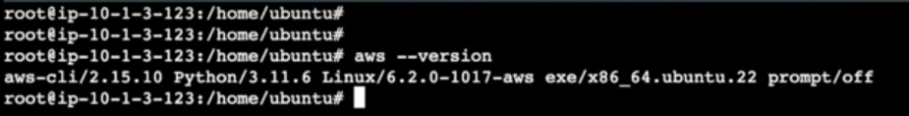

Now Install EKSCTL in server
Curl –silent –locatio https://github.com/weaveworks/eksctl/release/latest/download/esctl_$(uname -s)_amd64.tar.gz | tar xz –c /tmp

You can see in /tmp folder EKSCTL and move to below folder

Mv eksctl /usr/local/bin

Execute and check it is running as a command
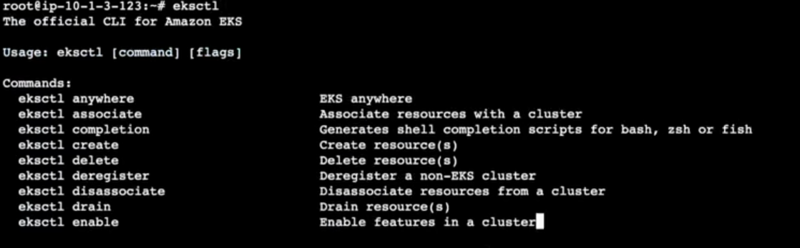
Now install Kubectl
curl –LO “https://dl.k8s.io/release/$(curl -L -s https://dl.k8s.io/release/stable.txt)/bin/linux/amd64/kubectl”

To execute kubectl in anywhere in the server then move to below path

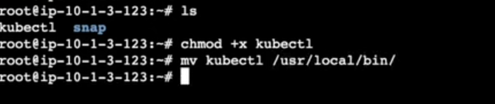

Node Creation:
Execute below command to create a Node if you found error like below , it means our node is searching for .AWS folder,
Eksctl create cluster –name “mycluster: --version 1.28 \ --zones=us-east-1a,us-east-1b,us-eat-1c –without-nodegroup

To resolve that issue use below command
Aws configure
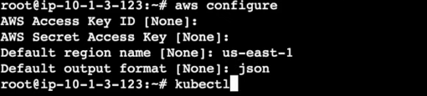
Once you ran above command then execute again Node creation command in Server, wait for sometime to deploy a cluster

Eksctl create cluster –name “mycluster: --version 1.28 \ --zones=us-east-1a,us-east-1b,us-eat-1c –without-nodegroup

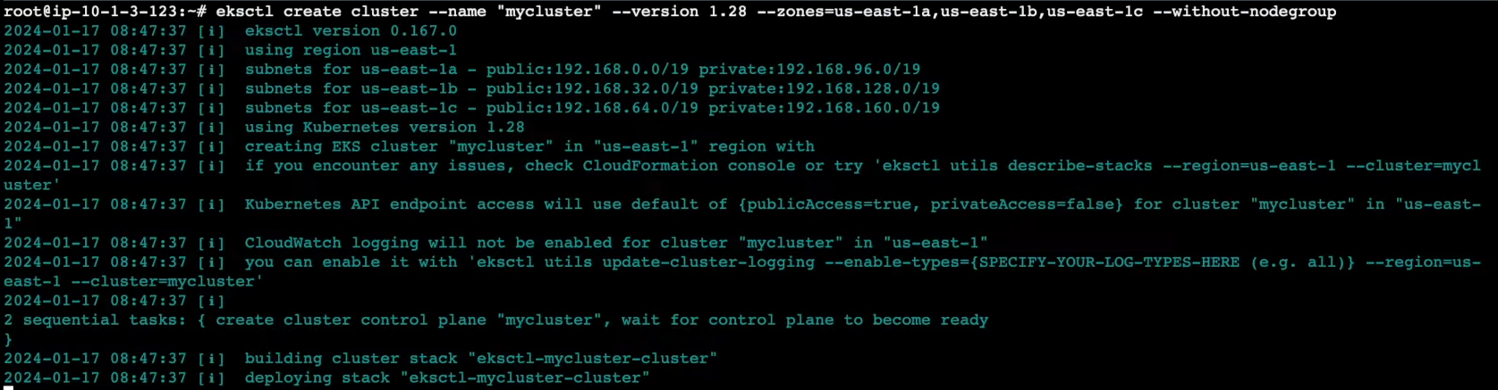

Go to the EKS Cluster wait for cluster creation.
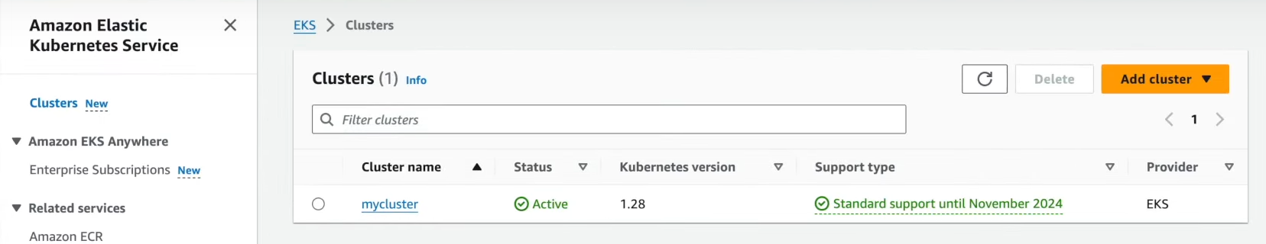

To reverify in command line use below command:
kubectl cluster-info

Instead of running Kubectl command covert that command into ALIAS like below
Alias k=kubectl
To create a utils for cluster use below command
Eksctl utils associate-iam-oidc-provider \ --region us-east-1 --cluster mycluster --approve

Create a Node group:
eksctl create nodegroup –cluster=mycluster –region=us-east-1 \
--name=mycluster-ng-1 –node-type=t2.micro \
--nodes=2 –nodes-min=2 –nodes-max=4 –node-volume-size=20 \
--ssh-access –ssh-public-key=corp_key \
--managed –asg-access –external-dns-access –full-ecr-access \
--appmesh-access –alb-ingress-access

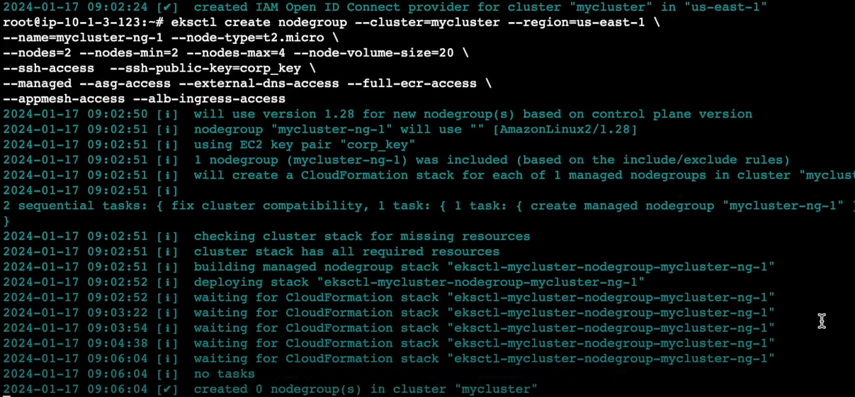

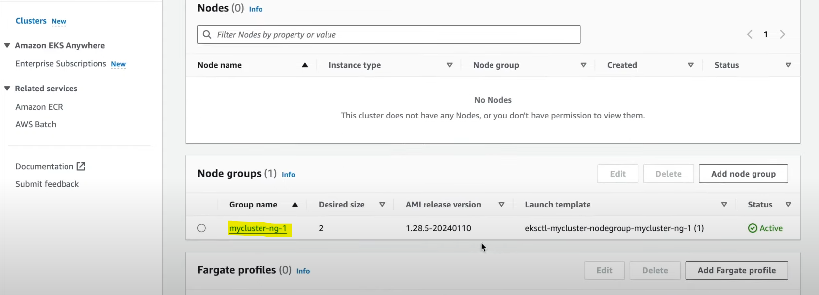
Confirm here you got 2 node servers created or not
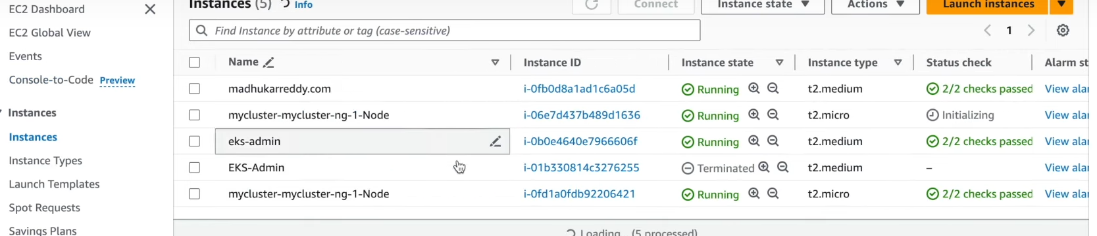

To list the nodes
Kubeclt get nodes

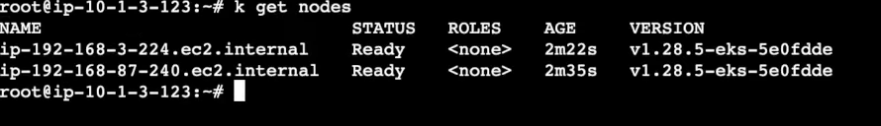

Start creating pod
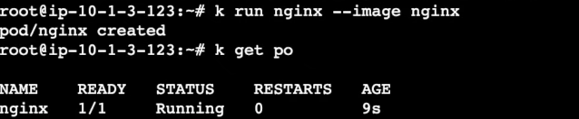
Expose the nginx pod
Kubectl expose pod nginx –port 80 –type NodePort
Check pod service
Kubectl get svc
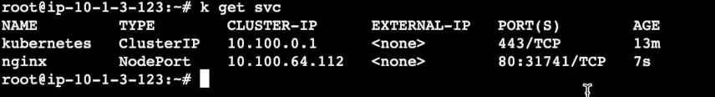
Once you exposed the service then check in chrome are you able to access Nginx
Here I have picked nodeport IP and nginx service port number
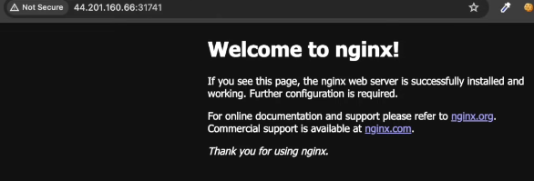
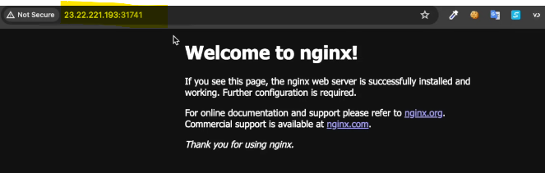

Here Nginx running in both nodes

To increase node

Go to EKS Clusters
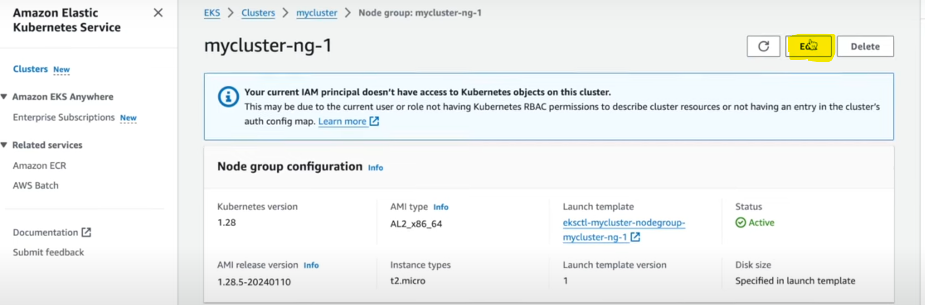
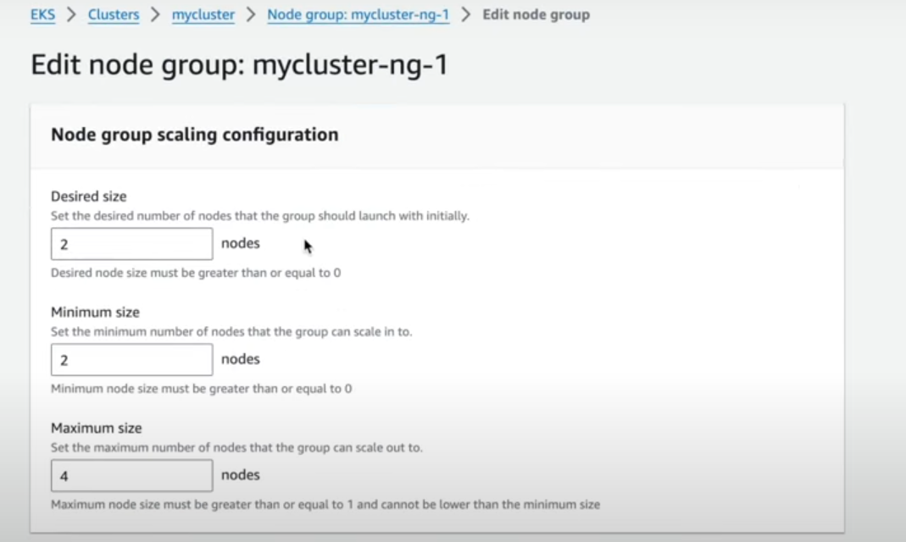
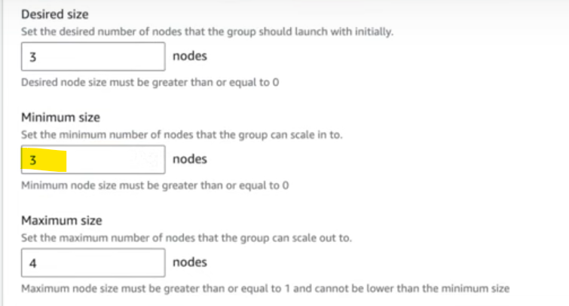

Then save it
It will increate another node

